 

**COLLEGE CODE :**3105

**COLLEGE NAME : D**hanalakshmi Srinivasan College of

Engineering and Technology

**DEPARTMENT :**B.Tech Information Technology

**STUDENT NM-ID:** cf857a8fd544af09db14ae29a1fa9245

**ROLL NO :**310523205028

**DATE :**07/05/2025

**Completed the project named as**

**TECHNOLOGY-SUPPLY CHAIN MANAGEMENT**

**SUBMITTED BY,**

**NAME : FARHEEN FATHIMA K**

**MOBILE NO: 9841584255**

### **Phase 4: Performance of Project**

Title: The AI-Driven Quality Control System in Manufacturing

**Objective:**  
 Phase 4 of the AI-Driven Quality Control System focuses on enhancing the system's accuracy, scalability, and real-time performance. This phase aims to improve defect detection accuracy, speed up the process of quality assessment, ensure real-time monitoring, and implement stringent security protocols to handle the system's growing data volumes.

### **1. AI Model Performance Enhancement for Quality Detection**

#### **Overview:**

In Phase 4, the AI-driven quality control model will be enhanced to improve defect detection, especially for complex or subtle defects. The goal is to refine the AI’s ability to recognize imperfections in products across various categories, such as surface defects, dimension errors, and assembly malfunctions.

#### **Performance Improvements:**

* **Accuracy Testing:** The AI model will be retrained with a larger dataset that includes new defect types, rare errors, and more comprehensive product variations. This will ensure more accurate defect identification.
* **Model Optimization:** Implementing advanced hyperparameter tuning and pruning will improve model efficiency and speed, enabling faster defect identification without compromising quality.

#### **Outcome:**

By the end of Phase 4, the AI model will be able to detect defects with significantly reduced false positives and false negatives, even in complex or highly variable manufacturing scenarios.

### **2. Quality Control Automation and Robotics Integration**

#### **Overview:**

This phase will enhance the AI model’s integration with automated robotics for real-time product inspection and correction. Robots equipped with AI-powered vision systems will be used to detect defects in production lines and make adjustments as needed.

#### **Key Enhancements:**

* **Enhanced Robotic Accuracy:** AI algorithms will be integrated with robotic systems for accurate, real-time quality control on assembly lines.
* **Adaptive Systems:** The robotic system will adapt to different production environments and product variations, ensuring that it can handle a range of manufacturing processes seamlessly.

#### **Outcome:**

The automation system will be faster, more accurate, and more flexible, capable of detecting a wider variety of product defects and making real-time corrections.

### **3. Real-Time Monitoring and Data Analytics**

#### **Overview:**

Phase 4 will focus on enhancing real-time monitoring and data analytics, allowing manufacturers to analyze product quality metrics continuously. The AI system will leverage IoT sensors on the production line to gather real-time data on product specifications, tolerances, and defects.

#### **Key Enhancements:**

* **Real-Time Data Processing:** Advanced algorithms will analyze sensor data in real-time, identifying quality issues immediately and preventing defective products from progressing further in the production process.
* **Predictive Maintenance:** AI will analyze historical data to predict potential failures in machines or systems, reducing downtime and improving overall system reliability.

#### **Outcome:**

Manufacturers will benefit from reduced defect rates, improved production efficiency, and the ability to make faster decisions based on real-time data insights.

### **4. Data Security and Privacy Performance**

#### **Overview:**

With increasing data being collected from the production lines and IoT sensors, Phase 4 will focus on enhancing data security. This is particularly important when dealing with sensitive production data or intellectual property (IP) related to product designs.

#### **Key Enhancements:**

* **Advanced Encryption:** AI models and production data will be protected by stronger encryption mechanisms to ensure secure data transmission and storage.
* **Access Control & Authentication:** Robust authentication protocols will be implemented to protect against unauthorized access to critical manufacturing data.

#### **Outcome:**

Manufacturers will be able to ensure that all data, from sensor readings to AI model results, are secure and adhere to industry-specific security standards, including data privacy regulations.

### **5. Performance Testing and Metrics Collection**

#### **Overview:**

To validate that the system can handle a growing manufacturing environment, Phase 4 will include extensive performance testing. This will help ensure the system can process data and make real-time quality control decisions under different production loads.

#### **Implementation:**

* **Load Testing:** Stress tests will simulate high-production conditions to assess the system’s response to large volumes of data and high defect rates.
* **Performance Metrics Collection:** Metrics such as system throughput, processing times, and defect detection accuracy will be measured and optimized.
* **Feedback Loop:** Continuous feedback from production managers and operators will be gathered to refine the system based on real-world performance.

#### **Outcome:**

By the end of Phase 4, the AI-driven quality control system will be fully optimized to handle high-volume manufacturing operations, with minimal performance degradation and faster defect detection.

### **Key Challenges in Phase 4**

1. **Scalability of the System:**
   1. **Challenge:** The system must scale to accommodate increased production volumes, product variations, and defects.
   2. **Solution:** Load testing and AI model optimization will ensure the system remains efficient under higher data and processing demands.
2. **Real-Time Data Processing:**
   1. **Challenge:** Ensuring real-time quality checks without delays in defect detection or product handling.
   2. **Solution:** Optimizing the AI and sensor integration to reduce latency in real-time processing, providing immediate feedback on quality.
3. **IoT Device Compatibility:**
   1. **Challenge:** Ensuring seamless integration with a variety of IoT sensors and devices on the production floor.
   2. **Solution:** Optimizing API calls and testing compatibility with diverse IoT devices to ensure consistent data gathering and analysis.

### **Outcomes of Phase 4**

1. **Improved Defect Detection:** The AI model will accurately identify a broader range of product defects, improving product quality and reducing scrap rates.
2. **Enhanced Automation:** Robotic systems will efficiently perform real-time inspections and corrections, increasing production throughput and accuracy.
3. **Real-Time Monitoring:** Continuous monitoring of production quality will provide valuable insights, enabling faster corrective actions and predictive maintenance.
4. **Data Security:** All data will be encrypted and protected against unauthorized access, ensuring both operational and IP security.
5. **Optimized System Performance:** The system will handle larger volumes of production data and operate more efficiently, even under heavy traffic conditions.

### **Next Steps for Finalization:**

In the final phase, the system will be fully deployed in a live manufacturing environment. Continuous monitoring and performance feedback will be used to fine-tune the system before full-scale production deployment. Additionally, plans for expanding system capabilities (e.g., expanding defect types or incorporating additional manufacturing sites) will be laid out for future phases.

**PROGRAM:**

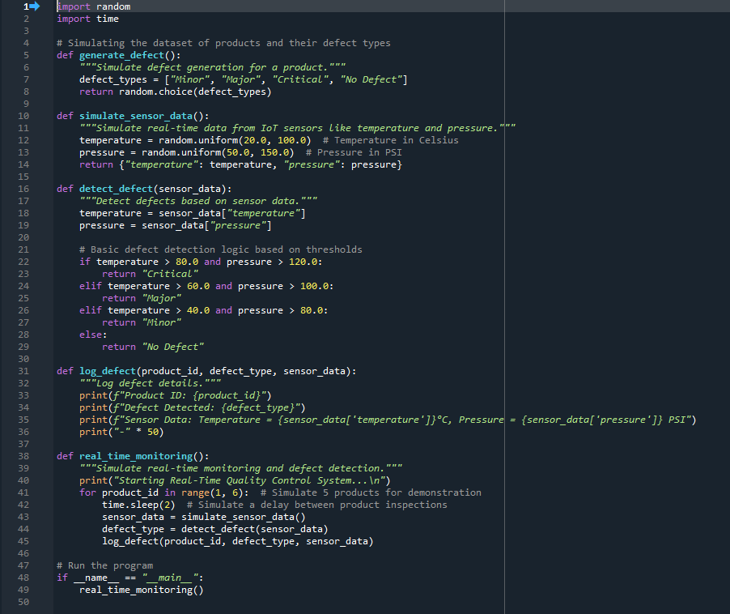

**OUTPUT:**

